**Spare Parts Inventory Optimization - Manufacturing Sector**

GOKULNATH K & E24755

**Overview**

Spare Parts Inventory Optimization in the manufacturing sector focuses on maintaining the right balance of spare parts to minimize downtime while controlling inventory costs. It involves analyzing usage patterns, demand forecasts, and lead times to ensure that critical parts are always available without overstocking. Techniques like ABC analysis, safety stock calculations, and predictive analytics help streamline the inventory process. Effective optimization reduces carrying costs, improves asset performance, and enhances overall production efficiency.

**Objective**

1. **Minimize Downtime**: Ensure critical spare parts are always available to prevent equipment failures from disrupting production and causing costly delays.
2. **Optimize Inventory Costs**: Balance inventory by reducing excessive stock, lowering carrying costs, and avoiding unnecessary capital investment in rarely used parts.
3. **Accurate Demand Forecasting**: Use data analytics and predictive models to forecast the demand for spare parts, ensuring timely procurement while preventing stockouts.
4. **Improve Asset Performance**: Enhance equipment reliability and efficiency by aligning spare parts availability with preventive and predictive maintenance schedules.
5. **Increase Operational Efficiency**: Streamline inventory management and procurement processes through automation, reducing manual errors, lead times, and administrative costs.

**Assigned Task(s)**

* Spare Parts Inventory Optimization - Manufacturing Sector

**Task Details**

* **Task 23 :** Spares Inventory Management and Optimization (SIMO) is an SKF process that consists of a systematic approach to reducing spares inventory costs. It is designed and developed for asset intensive process enterprises burdened with a large number of spare parts for mainte- nance, repair and operation (MRO).
* **Status:** Completed.
* **Details:**

1. Analyzed the essential fields like Part_ID, Part_Name, Current_Stock, Lead_Time_Days, Demand_Per_Month, Unit_Cost, and Criticality_Score.
2. These fields help to model the current inventory status and its importance to the business.
3. The total value of each part in the inventory is calculated by multiplying Current_Stock with Unit_Cost.
4. Parts with a Criticality Score of 5 are flagged as critical.
5. If the Current_Stock is less than the calculated Reorder Point, those parts are flagged for replenishment.
6. A bar chart visualizes the total inventory value for each part, helping stakeholders easily see high-value items.
7. The reorder point is calculated as: Reorder Point=Lead Time (days)×(Demand Per Month/30).
8. A scatter plot compares current stock to monthly demand, highlighting critical parts with color coding based on the Criticality Score.

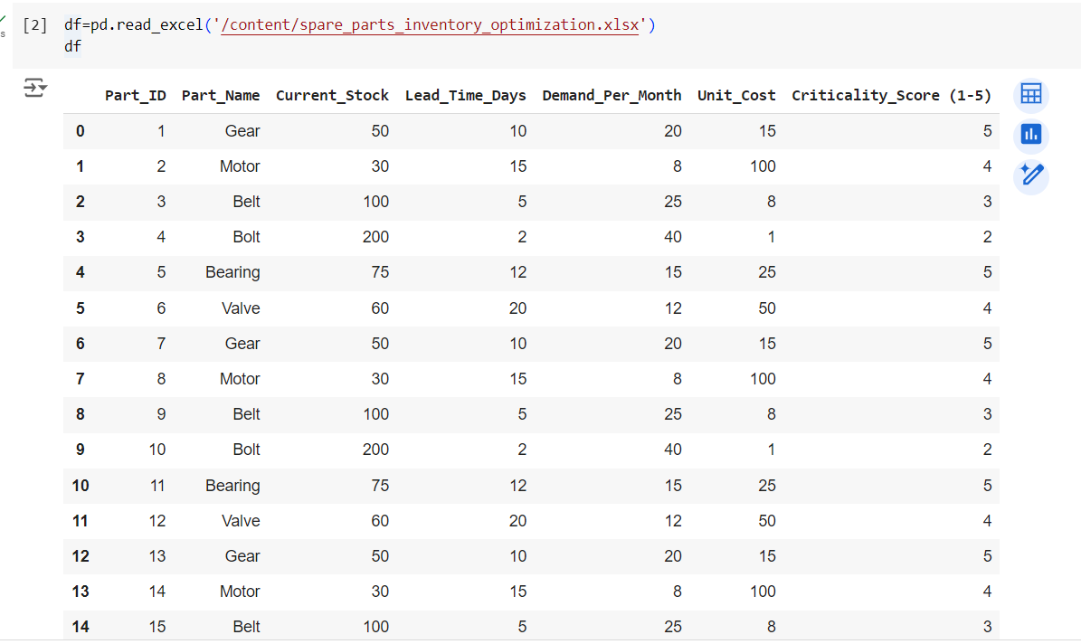

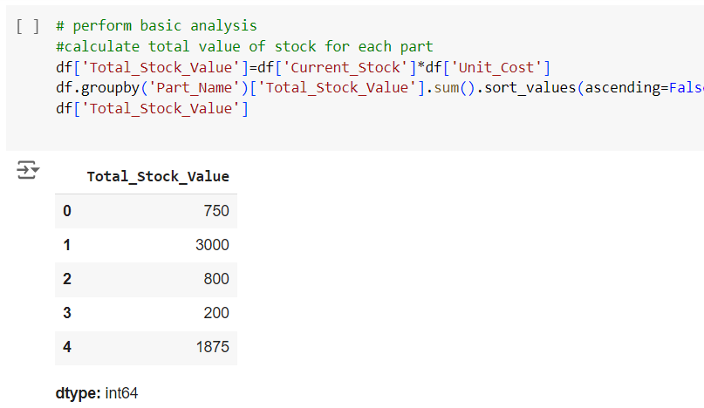

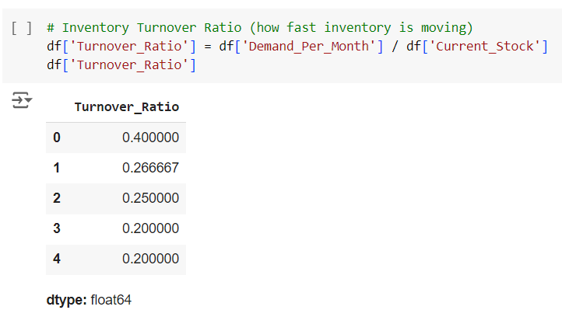

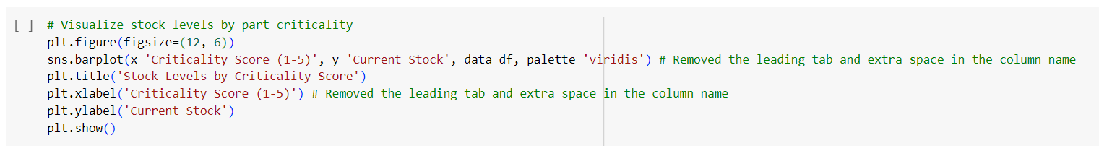

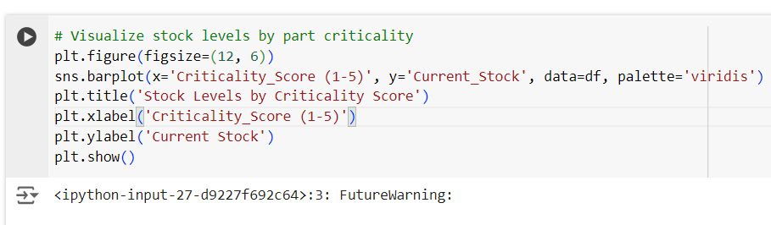

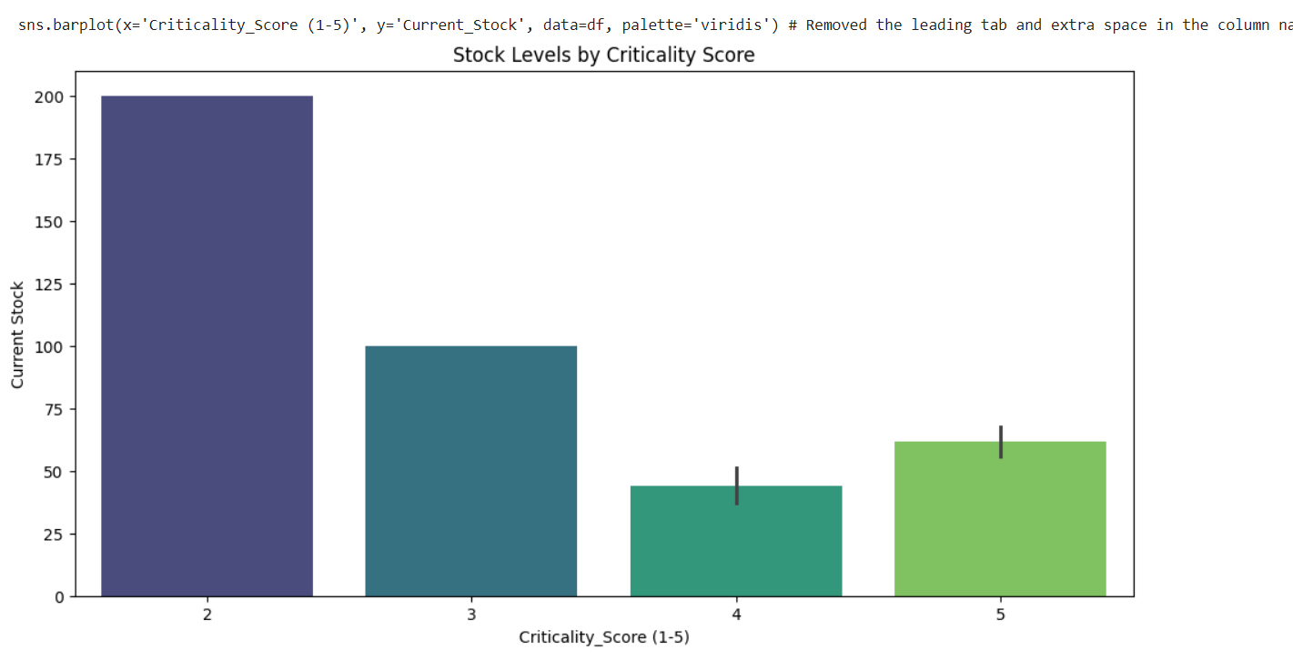

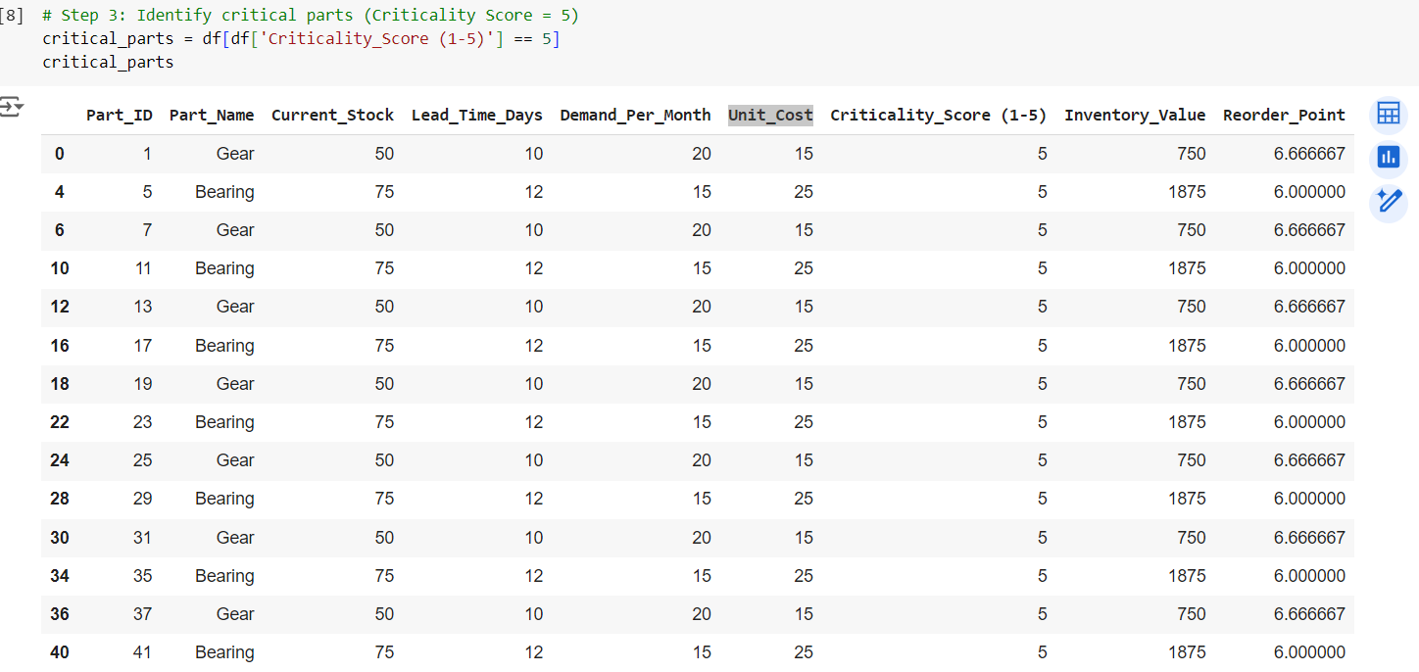

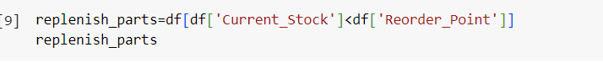

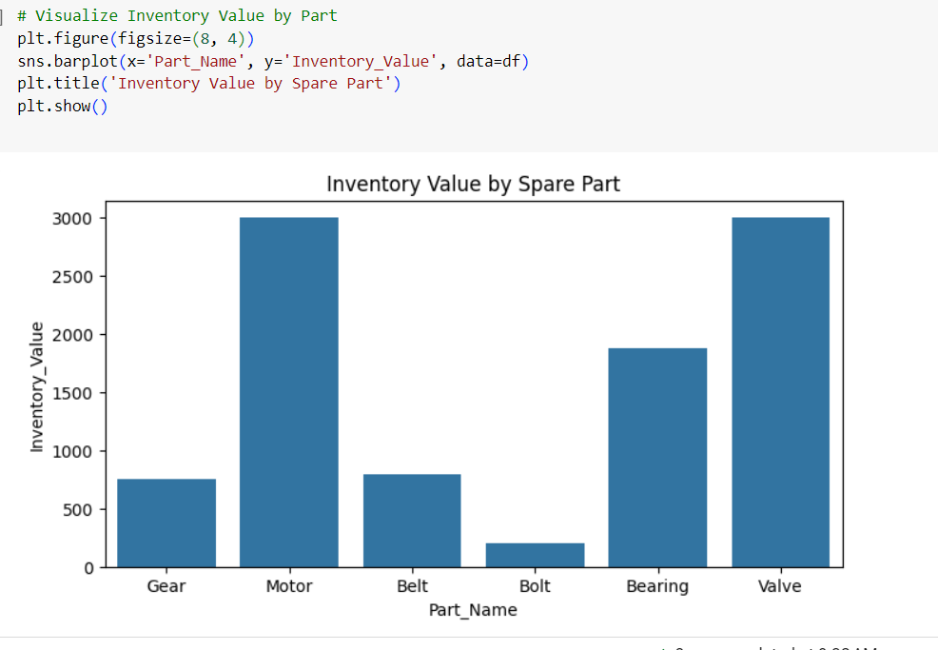

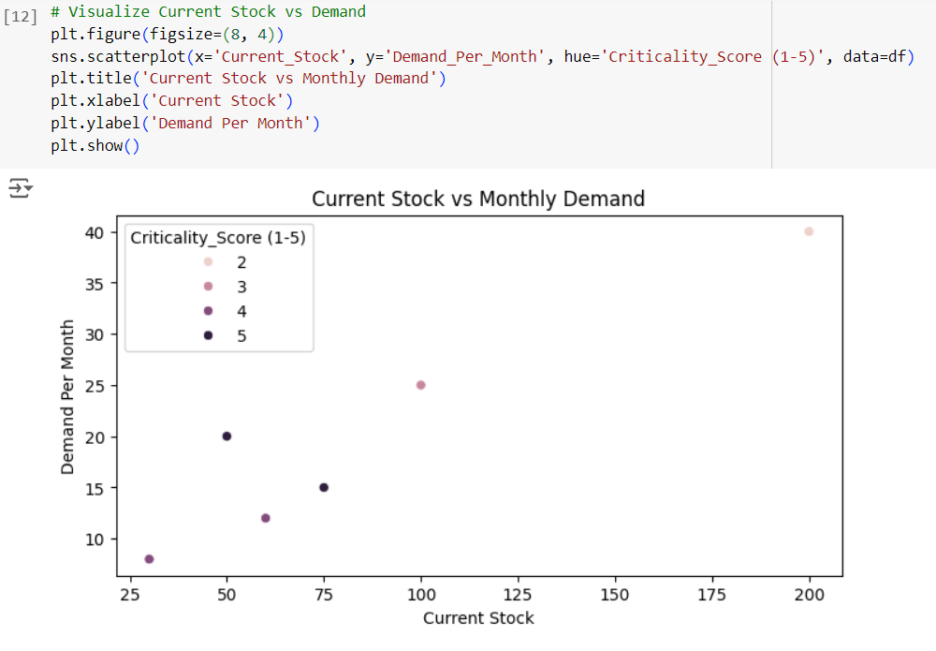

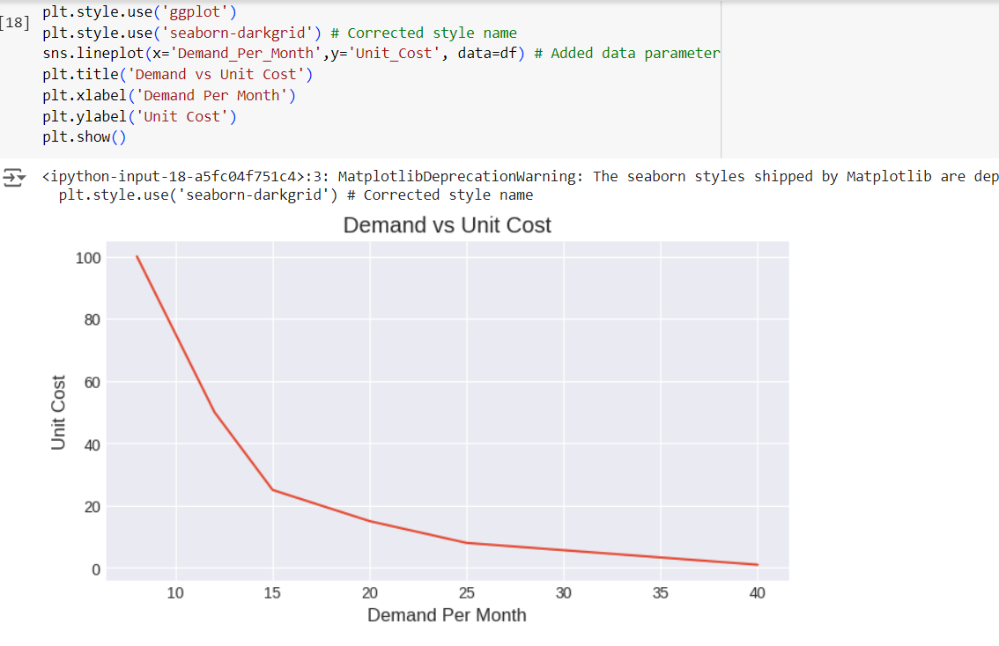

**Progress**

* **Accomplishments:**

1. Analyzed a system that tracks stock levels, demand, lead times, and criticality to support inventory decisions.
2. Calculated reorder points to ensure timely replenishment and avoid stockouts.
3. Flagged high-criticality parts for priority management, minimizing production risks.
4. Automated the process of identifying parts that need replenishment based on stock and demand.
5. Used data visualizations to provide clear insights into inventory value, stock levels, and demand trends.

* **Metrics:**

1. Inventory Value: The total monetary value of spare parts, calculated by multiplying current stock with unit cost.
2. Reorder Point: The threshold level for each part, calculated using lead time and demand, determining when to reorder.
3. Parts Needing Replenishment: Number of parts flagged for replenishment because their current stock is below the reorder point.
4. Critical Parts: Number or percentage of parts with a high criticality score (e.g., 5), indicating their importance to production.
5. Stock vs Demand Comparison: Analysis of whether the current stock meets the monthly demand, crucial for inventory planning.

**Challenges and Solutions**

* **Challenges Faced:**

1. Difficulty in ensuring high-criticality parts are always available, risking production delays.
2. Reordering too late or too early, leading to stockouts or overstock situations.
3. Managing high inventory costs while maintaining enough spare parts for smooth operations.
4. Fluctuations in part demand make it hard to predict how much stock is needed.
5. Unpredictable lead times from suppliers cause delays in part availability.

* **Solutions Implemented:**

1. Assigning higher focus to critical parts using a criticality score to prevent stockouts.
2. Implementing precise reorder point calculations based on lead time and demand.
3. Tracking inventory value to minimize excessive stock while maintaining availability.
4. Using historical data to better predict demand and adjust stock levels accordingly.
5. Working closely with suppliers to reduce lead time variability and ensure timely replenishment.

**Next Steps**

* **Upcoming Tasks:** To face upcoming tasks in this sector, focus on enhancing predictive analytics, optimizing stock levels, improving supplier collaboration, and integrating real-time inventory monitoring systems.
* **Goals:** To achieve the goals, streamline inventory processes with data-driven decisions, improve forecasting accuracy, and ensure efficient resource allocation for critical parts.

**Conclusion**

* **Summary:** The analysis of Spare Parts Inventory Optimization highlights the importance of data-driven strategies in managing inventory efficiently. By leveraging predictive analytics and real-time monitoring, organizations can significantly reduce costs and improve service levels. Ultimately, optimizing spare parts inventory leads to enhanced operational performance and customer satisfaction.
* **Acknowledgments:** Thank you all for your attention and engagement during this presentation.